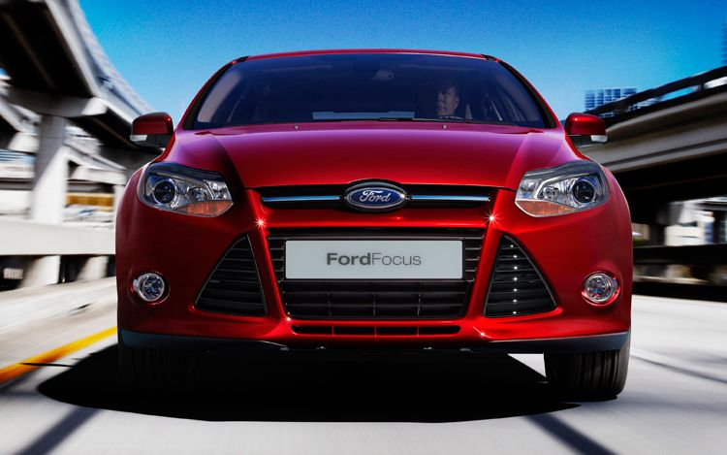
Finally, Ford gives us the European Focus we're been coveting for years. The 2011 Ford Focus is actually a global car that will be about 80% identical in every market. Even the front fascia is the same around the world.
As a 2011 model, the third-generation Focus, whether in four-door sedan or five-door hatchback form, will be nearly identical in all markets. Ford's European small and medium vehicle center in Germany led development. Powertrain engineering occurred in Ford's technical center in England. Ford put its European driving dynamics specialists in charge of ride and handling. This is as European as it gets.
But there's better news: Ford says it's using identical chassis and suspension architecture in all markets, except for minor regional tuning differences. That means the torque vectoring Dynamic Cornering Control system -- added by those special driving dynamics folk -- is coming our way. It transfers power between the drive wheels to reduce understeer, and improve traction and turn-in.
The rear suspension is an updated version of the independent multi-link (Ford calls it "Control Blade") found in previous Focus models. Torsional rigidity is up 25% over the current North American Focus, thanks to extensive use of high-strength steel (comprising 55% of the body shell). Ultra-high-strength and Boron steels account for 26%. Ford says these materials help the Focus meet crash legislation across world markets and minimize vehicle weight.
While global powertrain options include an EcoBoost four-cylinder and a line of common-rail diesel engines, an all-aluminum 2.0L I-4 leads the way in the U.S., producing 155 horsepower and 145 ft.-lb. of torque. The E85-capable engine features direct injection, allowing a 12:1 compression ratio, and variable cam timing on the intake and exhaust valves -- Ford calls it Twin Independent Variable Camshaft Timing, or Ti-VCT.
While designing the engine, Ford engineers sought minimize friction to improve efficiency, adding an electric power assist steering system and an overrunning alternator decoupler, which allows the alternator and water pump to operate at a lower tension.
A six-speed dual-clutch transmission (PowerShift in Ford nomenclature) comes standard. Ford has supplanted the manual with the dual-clutch, citing it as the new fuel economy leader. The PowerShift functions like a standard automatic, but its two clutches allow near instantaneous shifts and improved fuel economy. Tied to the gearbox is Hill Start assist, which holds the brakes for 2.5 seconds to prevent rollback on an incline. The system activates when the incline exceeds 3%.
Ford's well-received SYNC system is available in the Focus, with its voice-controlled Bluetooth, navigation, and portable media device integration. Joining the connectivity package is MyFord, which is a combination of controls and display screens that operate vehicle features. On high-end spec, the system features an eight-in touch screen. Also available are a start button, rearview camera, and an automated parallel parking system
The next Focus enters production in late 2010, and it will arrive in markets come early 2011. Finally, the European Focus is here. Now, how about that hot-hatch RS model?

